Sample FERPA/3rd Party Script
Start the appointment with an introduction of yourself and overview of the NSO appointment. Help set the tone by including your expectations and procedures, such as:
- We have about an hour and 15 minutes together today, and we have a lot to cover.
- We will review your Advising Pass, pre-enrollment, and test scores. Then, I will ask you to share your screen so that I can help you add courses to your plan. Then, we will move on to build your schedule and register for classes.
- Afterwards, I will email you a summary of our appointment, and refer you to additional help with advising and registration if need be.
- Do you have any questions before I move on?
Let the student know whether or not you are their assigned major advisor.
Verify student’s identity (ID number, user name, or home address).
Ask if anyone else is present in the conference. Regardless, it is helpful to let students know a little bit about advising expectations and FERPA:
- Academic advising appointments are typically between an advisor and student only. Let me know if you ever want someone else to join us.
- This is due, in part, to a federal education privacy law called “FERPA.” FERPA prevents any university personnel from sharing information about your grades or degree progress without your permission.
- We treat students as adults, and expect that you will share information with your (parent/person) if you choose, outside of the advising appointment, on your own time.
If more information is needed, you may wish to read the official language:
- The Family Educational Rights and Privacy Act (FERPA) is a Federal law that protects the privacy of student education records. FERPA gives parents certain rights with respect to their children's education records. These rights transfer to the student when he or she reaches the age of 18 or attends a school beyond the high school level. (https://www2.ed.gov/policy/gen/guid/fpco/ferpa/index.html)
If the person doesn’t offer to excuse themselves, or the student doesn’t ask them to leave, continue as follows:
- In order to continue the appointment with (person) in the room, I need you to complete a release of information form online. Or, if you have done that already, I can verify it.
Advisor link: https://ferpareleases.indiana.edu/employees will require CAS login, and then you can search by the student’s last name, username, or University ID number.
If the student has not submitted a release, the screen will say “No results found for your search.”
- There is no release on file. (Student), if you wish to have (person} present during the advising meeting, or release any other information, you may complete a release at https://ferpareleases.indiana.edu/. You can return to this link to edit your preferences and PIN at any time.
If the student has submitted a release, the following will appear:
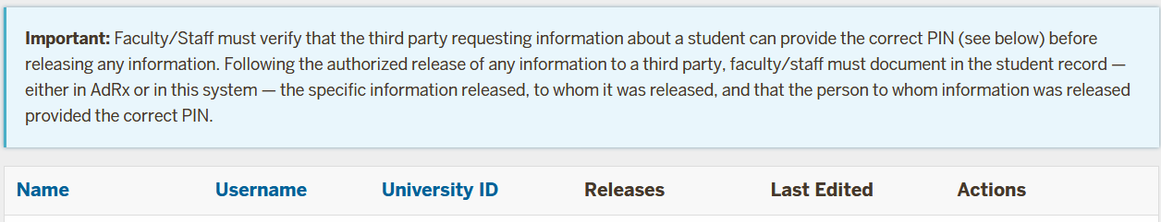
Under “Releases” you should see a link to “Validate PIN.” Click on that link and you should see “Verify FERPA PIN for (Student Name)’s Releases” and space to enter the 6-digit PIN. As noted above, the person(s) asking to attend the advising meeting should provide the PIN.
Once the PIN is entered, you should be able to see what information the student has released to be shared.
- (Student), I see that you have a release on file for (person). The release shows that I have permission to share (what information is indicated). Is this still okay with you?

